Scheduling Procedures for Learning Centers

Initial Scheduling Steps
- Replication of previous like semester courses are rolled forward to new term.
ITS will roll forward all approved courses/sections from last like semester for departmental review and modification during Planner open window.

- Learning Centers to date are: Admiralty Centre, Birchwood Fields, Briar Cliff University, Iowa Center for Higher Education, John and Mary Pappajohn Education Center, Paderno del Grappa, Scott Community College, Tippie College of Business Cedar Rapids

In order for a course to be picked up on any kind of reporting for Learning Centers, the course must be set up as indicated. The Learning Center field in the time/location area is the trigger for reporting and appropriate tuition assessment.

Learning Centers with Building and Room
- Courses that are to be associated to JPEC, Tippie College of Business Cedar Rapids and Birchwood Learning Center will be entered in the following way since they have a building and rooms associated to them.
  - Classroom Scheduling Manages Initial Room Assignment – “No”
  - Is off-site – “Yes”
  - Is Learning Center – “Yes”
  - Select Correct Learning Center from pulldown menu
  - Select building in pulldown menu
  - Birchwood = BLC
  - John and Mary Pappajohn Education Center = PEC
  - Tippie College of Business Cedar Rapids = CBCR
  - Select desired room in pulldown menu

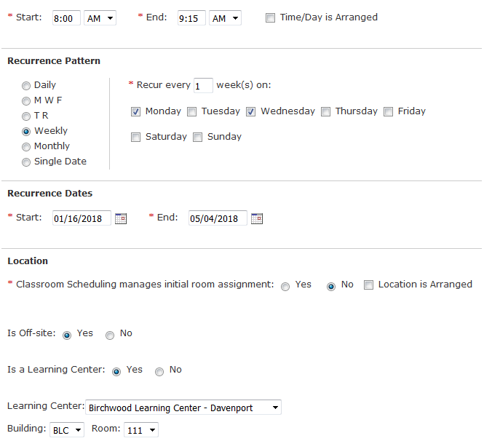

Learning Centers without Building and Room
- Learning Centers without building and room are: Admiralty Centre; Briar Cliff University; Paderno del Grappa; Scott Community College; and would be entered this way:

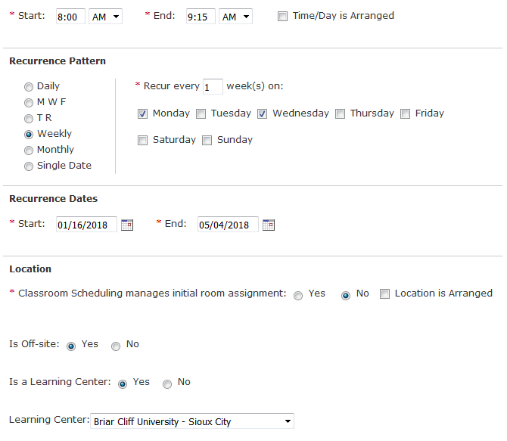

*** Please do not use the “off site” information area for Learning Centers. Addresses are directly related to the Learning Centers. Once selected via the pull down menu, it will populate the time/location area with that information.

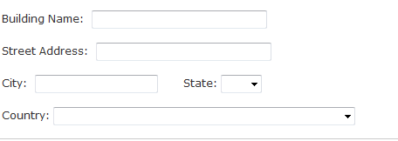
Don’t Use for Lea

Iowa Center for Higher Education Learning Center

- ICHE/KFAB is the only Learning Center that contains University Classrooms. Approved departments to utilize ICHE/KFAB to date are - Entrepreneurship (ENTR); Political Science (POLI); Spanish (SPAN); Sports & Rec Management (SRM); School of Social Work (SSW)

- Course offerings associated to the ICHE Learning Center must use the “Management Type “DCE ICHE Dist Crs (EX*).

- Courses that are to be associated to ICHE Learning Center but do not require a room in KFAB must be entered in the following manner via the time/location area in the MAUI course offering:

  - Classroom Scheduling Manages Initial Room Assignment – “No”
  - Is off-site – “Yes”
  - Is Learning Center – “Yes”
  - Select Correct Learning Center from pulldown menu

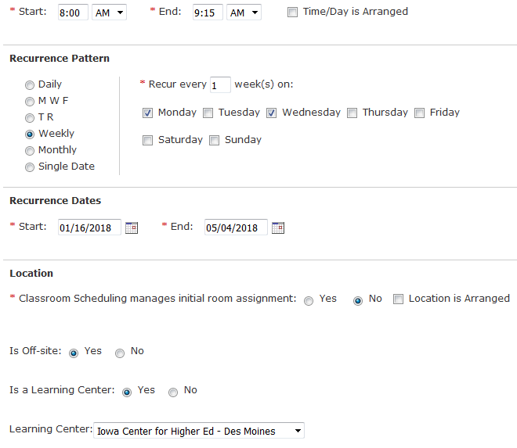

- Course offerings that are to be associated to the ICHE Learning Center and are requiring a room in KFAB will need to be entered in the following manner via the time/location area in the MAUI course offering:

A time and day must be entered if a KFAB room is required
Classroom Scheduling Manages Initial Room Assignment – “Yes”
In Room Preference Field – indicate a room in KFAB is desired

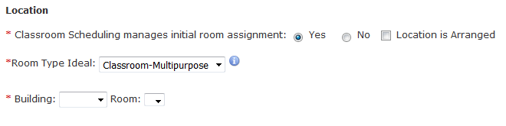
Learn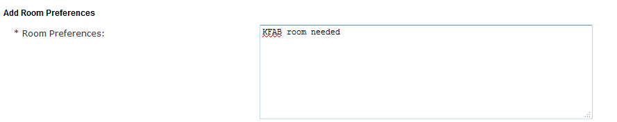

Classroom Scheduling will provide the best fit room for the course offering. If the distance education room (307) is required departments would need to indicate that in the “room preference” field as well.

